Alan Ritlhabile Chauke



A.D.A.P.T Process document

ST10445966 POE Part 1

Table of Contents

# Cover page

# Introduction

* **Project objectives**
* **Target audience**
* **Purpose**

# Idea and Choice explanation

* **Organization name**
* **Organization type**
* **Focus**
* **Paragraph of choice explanation**

# Contacts

## Introduction

Project objectives: Creating a website for an NGO.

Target audience: People who are fighting against GBV (Gender-Based Violence), Domestic violence and child abuse.

Purpose: To bring people to an epiphany about the rise of domestic violence in the country

## Idea and Choice Explanation

Organization name: Agisanang Domestic Abuse Prevention & Training

Organization type: None-Governmental Organization

Focus: Domestic abuse prevention and training

### Paragraph:

According to Brian (2023), “According to research, South Africa is considered a country with [high cases of domestic violence](https://www.dailymaverick.co.za/article/2023-05-30-statistic-of-out-of-control-violence-969-women-murdered-in-south-africa-in-just-three-months/). Statistics reported for 2023 suggest that over 15 000 women were victims of physical and sexual assault. Additionally, more than 960 women were killed because of domestic violence related cases.”

The whole purpose of this website is to make sure that the cries of domestic violence victims are heard. Many are fatherless because of this abominable and hideous act, and many are also motherless. Many of them are lying in their graves. To think that the last minutes of their lives were nothing but pain and sorrow all because they trusted someone and loved them so much, with no thought of being killed by them dawning on them.

As an organization, we refuse to tolerate such a heinous act in the community, let alone the entire country. With this website, we will be able to reach out to people suffering from any domestic violence with just a press of a button. The button will set an alarm to the head quarters of the organization, sending us your location and we will come to the rescue. Not only that; you can also book a counselling session with social workers who will be there for you throughout your healing period in your local areas and booking self-defence sessions using the website.

As said before, our goal is to save lives from domestic violence, and put smiles on the faces of victims.



[facebook.com](https://www.facebook.com/Adapt.rsa/photos_by/)

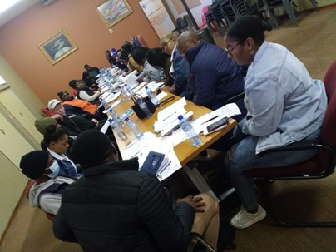

[Facebook](https://web.facebook.com/photo.php?fbid=585169397124086&set=pb.100068930927220.-2207520000&type=3)

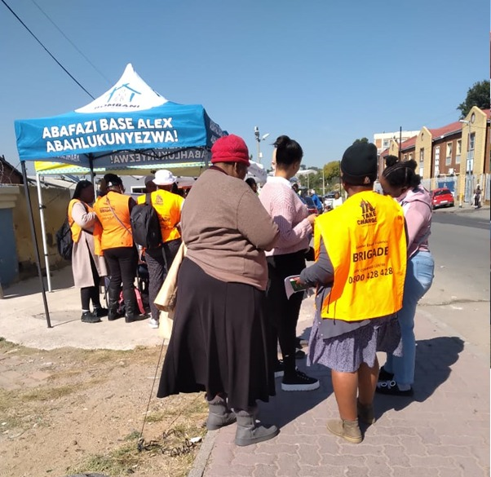

[Facebook](https://web.facebook.com/photo.php?fbid=585167060457653&set=pb.100068930927220.-2207520000&type=3)

#### Contacts

Telephone: +27 11 786 6608

Facebook: **Agisanang Domestic Abuse Prevention & Training**

[**Agisanang Domestic Abuse Prevention and Training | Facebook**](https://web.facebook.com/Adapt.rsa/photos_by/?_rdc=1&_rdr)

Address: Oliver Tambo Community Centre,

128 2nd Street,

Wynberg, 2090

Location Sandton, Gauteng, South Africa

# Referencing List

Brian. 2023. *Domestic violence in South Africa: Gendered crime.* [Online]. Available at: [1 new message (ier.co.za)](https://www.ier.co.za/domestic-violence-in-south-africa-a-gendered-crime/) [Accessed: 05 August 2024].

Agisanang domestic abuse prevention & training. 2023. [Online]. Available at: [Agisanang Domestic Abuse Prevention and Training | Facebook](https://web.facebook.com/Adapt.rsa/photos_by/?_rdc=1&_rdr) [Accessed: 05 August 2024].